Міністерство освіти і науки України

Національний технічний університет України „КПІ”

Факультет інформатики та обчислювальної техніки

Кафедра автоматизованих систем обробки

інформації та управління

**ЗВІТ**

до лабораторної роботи № 7

з предмету:

„Основи технологій програмування”

|  |  |  |  |  |
| --- | --- | --- | --- | --- |
| **Виконав**  **студент** |  | *ІП-61 Кушка Михайло Олександрович, 2-й курс, ІП-6116* |  |  |
|  |  | (№ групи, прізвище, ім’я, по батькові, курс, номер залікової книжки) |  |  |
|  |  |  |  |  |
| **Прийняв** |  | *Подрубайло О.О.* |  |  |
|  |  | (посада, прізвище, ім’я, по батькові ) |  |  |

Київ 2018

ЗМІСТ

1. постановка задачі 3

2. Діаграма класів 4

3. Висновок 5

4. Код програми 6

# постановка задачі

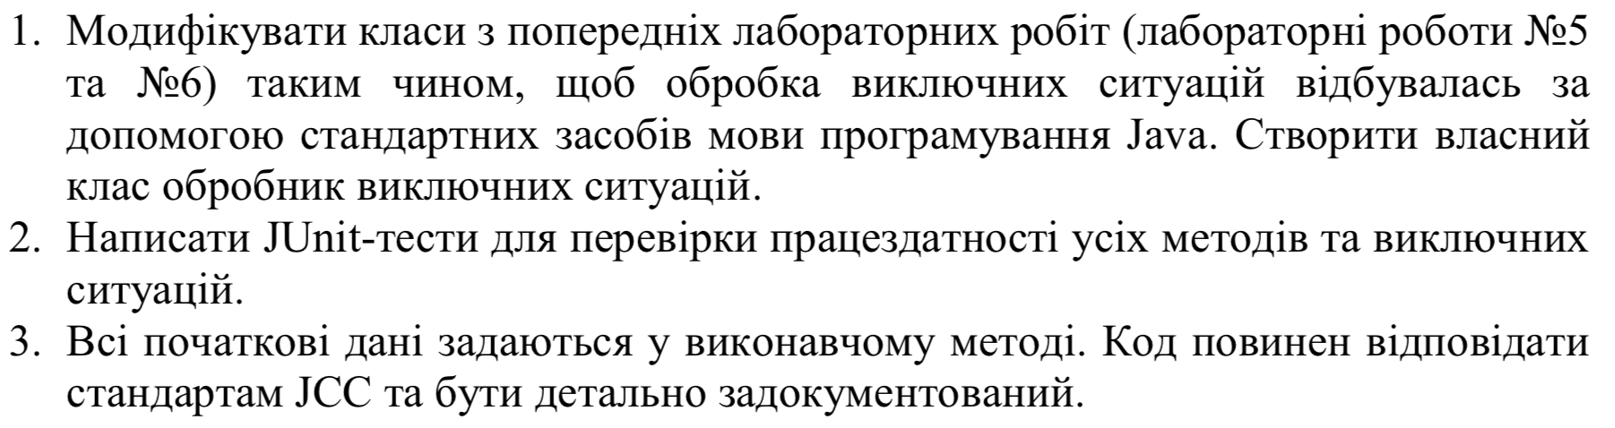

# Діаграма класів

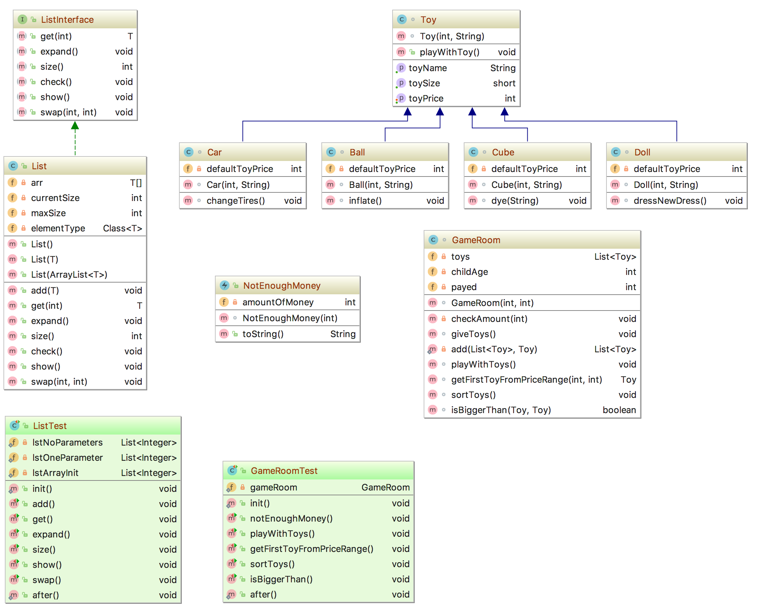

# Висновок

Були складнощі з настроюванням junit тестів у Inteliij Idea в зв’язку з існуванням 5-ї версії junit, що на даний момент є бета-версією. Після того, як вдалося запустити перший тест, створення інших тестів не викликало жодних проблем.

# Код програми

**import** java.util.ArrayList;  
  
*/**  
 * Java labs – Lab7  
 \** ***@version*** *1.0 2018-04-07  
 \** ***@author*** *Misha Kushka  
 */***public class** Main {  
  
 **public static void** main(String[] args) {  
  
 *// Init game room's object to play with it.* GameRoom gameRoom = **new** GameRoom(0, 12);  
  
 gameRoom.playWithToys();  
  
 System.***out***.println(**"\n-- SORTED ------------------------------"**);  
  
 gameRoom.sortToys();  
 gameRoom.playWithToys();  
  
 System.***out***.println();  
  
 **int** min = 5;  
 **int** max = 13;  
  
 Toy firstToyFromRange = gameRoom.getFirstToyFromPriceRange(min, max);  
  
 **if** (firstToyFromRange != **null**) {  
 System.***out***.println(**"Toy from "** + min + **" to "** + max + **" is "** + firstToyFromRange.getToyName() + **"."**);  
 } **else** {  
 System.***out***.println(**"There is no toys from range ("** + min + **", "** + max + **")"**);  
 }  
  
 }  
  
}

*/**  
 * Ball toy for girls & boys of different ages.  
 */***class** Ball **extends** Toy {  
  
 **private int defaultToyPrice** = 1; *// price of the toy, not considering child age  
  
 /**  
 * Call's the constructor of the parent's Toy class,  
 * sets toy's price, which isn't depends on the age  
 * of the child.  
 *  
 \** ***@param childAge*** *Age of the child.  
 \** ***@param newToyName*** *Name of the toy.  
 */* Ball(**int** childAge, String newToyName) {  
 **super**(childAge, newToyName);  
 setToyPrice(**defaultToyPrice**);  
 }  
  
 */**  
 * Some another method for this class.  
 */* **void** inflate() {  
 System.***out***.println(**"Inflate the ball."**);  
 }  
  
}

*/**  
 * Car toy for boys of different ages.  
 */***class** Car **extends** Toy {  
  
 **private int defaultToyPrice** = 3; *// price of the toy, not considering child age  
  
 /**  
 * Call's the constructor of the parent's Toy class,  
 * sets toy's price depends of the default toy price  
 * and age of the child.  
 *  
 \** ***@param childAge*** *Age of the child.  
 \** ***@param newToyName*** *Name of the toy.  
 */* Car(**int** childAge, String newToyName) {  
 **super**(childAge, newToyName);  
 setToyPrice(**defaultToyPrice** * getToySize());  
 }  
  
 */**  
 * Some another method for this class.  
 */* **void** changeTires() {  
 System.***out***.println(**"Now your car is equiped with the new tires."**);  
 }  
  
}

*/**  
 * Cube toy for girls & boys of different ages.  
 */***class** Cube **extends** Toy {  
  
 **private int defaultToyPrice** = 4; *// price of the toy, not considering child age  
  
 /**  
 * Call's the constructor of the parent's Toy class,  
 * sets toy's price depends of the default toy price  
 * and age of the child.  
 *  
 \** ***@param childAge*** *Age of the child.  
 \** ***@param newToyName*** *Name of the toy.  
 */* Cube(**int** childAge, String newToyName) {  
 **super**(childAge, newToyName);  
 setToyPrice(**defaultToyPrice** * getToySize());  
 }  
  
 */**  
 * Some another method for this class.  
 */* **void** dye(String color) {  
 System.***out***.println(**"Now color of the your cube is "** + color + **"."**);  
 }  
  
}

*/**  
 * Doll toy for girls of different ages.  
 */***class** Doll **extends** Toy {  
  
 **private int defaultToyPrice** = 5; *// price of the toy, not considering child age  
  
 /**  
 * Call's the constructor of the parent's Toy class,  
 * sets toy's price depends of the default toy price  
 * and age of the child.  
 *  
 \** ***@param childAge*** *Age of the child.  
 \** ***@param newToyName*** *Name of the toy.  
 */* Doll(**int** childAge, String newToyName) {  
 **super**(childAge, newToyName);  
 setToyPrice(**defaultToyPrice** * getToySize());  
 }  
  
 */**  
 * Some another method for this class.  
 */* **void** dressNewDress() {  
 System.***out***.println(**"Now your doll wears in the new dress."**);  
 }  
  
}

*/**  
 * Implementation of the gaming room for children  
 * of different ages.  
 */***class** GameRoom {  
  
 **private** List<Toy> **toys** = **new** List<>(); *// array of toys in the game room* **private int childAge**; *// age of the child* **private int payed**; *// how much was payed for the room  
  
 /**  
 * Check is there are enough money to visit the game room.  
 */* **private void** checkAmount(**int** amount) **throws** NotEnoughMoney {  
 **if** (amount < 1) {  
 **throw new** NotEnoughMoney(amount);  
 }  
 }  
  
 */**  
 * Allow to pay for playing in the game room.  
 * Depending on the amount of money child can  
 * play with different number of toys.  
 *  
 \** ***@param amount*** *Amount of money to pay for playing.  
 \** ***@param age*** *Age of the child in the room.  
 */* GameRoom(**int** amount, **int** age) {  
 *// Too low payment checker.* **try** {  
 checkAmount(amount);  
 } **catch** (NotEnoughMoney e) {  
 System.***out***.println(**"Error: "** + e);  
 }  
 **childAge** = age;  
 **payed** = amount;  
  
 *// Fill toys array with toys.* giveToys();  
  
 *// Show how many toys are available depends of the payed amount.* **try** {  
 System.***out***.println(**"Now you can play with "** + **toys**.size() + **" toys."**);  
 } **catch** (NullPointerException e) {  
 System.***err***.println(**"Add elements to the toys array first."**);  
 System.*exit*(2);  
 }  
 }  
  
 */**  
 * Fill the toys array with different toys object's  
 * depends of the payed amount for the room.  
 */* **void** giveToys() {  
  
 *// Toys, which are in the room.* List<Toy> defaultToys = **new** List<>();  
  
 defaultToys.add(**new** Car(**childAge**, **"super car"**));  
 defaultToys.add(**new** Doll(**childAge**, **"cool doll"**));  
 defaultToys.add(**new** Ball(**childAge**, **"amazing ball"**));  
 defaultToys.add(**new** Cube(**childAge**, **"crazy cube"**));  
  
 **int**[] defaultToyPrices = **new int**[defaultToys.size()]; *// prices of toys in the room  
  
 // Set prices for all toys in the room depending on the child age.* **for** (**int** i = 0; i < defaultToyPrices.**length**; i++) {  
 defaultToyPrices[i] = defaultToys.get(i).getToyPrice();  
 }  
  
 **int** totalPrice = 0; *// total price of all toys for the current child* **int** iteration = 0; *// number of iterations of adding toys  
  
 // A little bit randomly choose toys for the particular child  
 // depending on the child age and payed amount.* **while** (totalPrice < **payed**) {  
 **switch** (iteration%4) {  
 **case** 0:  
 **if** (totalPrice + defaultToyPrices[0] <= **payed**) {  
 **toys** = *add*(**toys**, defaultToys.get(0));  
 totalPrice += defaultToyPrices[0];  
 }  
 **break**;  
 **case** 1:  
 **if** (totalPrice + defaultToyPrices[1] <= **payed**) {  
 **toys** = *add*(**toys**, defaultToys.get(1));  
 totalPrice += defaultToyPrices[1];  
 }  
 **break**;  
 **case** 2:  
 **if** (totalPrice + defaultToyPrices[2] <= **payed**) {  
 **toys** = *add*(**toys**, defaultToys.get(2));  
 totalPrice += defaultToyPrices[2];  
 }  
 **break**;  
 **default**:  
 **if** (totalPrice + defaultToyPrices[3] <= **payed**) {  
 **toys** = *add*(**toys**, defaultToys.get(3));  
 totalPrice += defaultToyPrices[3];  
 }  
 **break**;  
 }  
 iteration++;  
 }  
  
 System.***out***.println(**"Total price: $"** + totalPrice);  
  
 }  
  
 */**  
 * Add element to the Toy's array.  
 *  
 \** ***@param originalArray*** *Array to put element into.  
 \** ***@param newItem*** *Element to put.  
 \** ***@return*** *New array with added element.  
 */* **private static** List<Toy> add(List<Toy> originalArray, Toy newItem) {  
 **int** currentSize = originalArray.size();  
 List<Toy> tempArray = **new** List<>();  
 **for** (**int** i = 0; i < currentSize; i++) {  
 tempArray.add(originalArray.get(i));  
 }  
 tempArray.add(newItem);  
 **return** tempArray;  
 }  
  
 */**  
 * Execute method of playing with all toys  
 * of the particular child.  
 */* **void** playWithToys() {  
 **for** (**int** i = 0; i < **toys**.size(); i++) {  
 **toys**.get(i).playWithToy();  
 }  
 }  
  
 */**  
 * Get first toy from the setted range by toy's price.  
 *  
 \** ***@param min*** *Minimum price of the toy to find.  
 \** ***@param max*** *Maximum price of the toy to find.  
 \** ***@return*** *First toy with price from range if found,  
 * or null otherwise.  
 */* Toy getFirstToyFromPriceRange(**int** min, **int** max) {  
  
 *// Check is min < max.* **if** (min > max) {  
 System.***out***.println(**"Attention! min value is bigger, than max value!"**);  
 }  
  
 *// Iteratively find toy from the given range.* **for** (**int** i = 0; i < **toys**.size(); i++) {  
 **if** (**toys**.get(i).getToyPrice() >= min && **toys**.get(i).getToyPrice() <= max) {  
 **return toys**.get(i);  
 }  
 }  
  
 **return null**;  
 }  
  
 */**  
 * Sort toys by the name of their classes alphabetically.  
 */* **void** sortToys() {  
 **int** i, j; *// iterators* **int** n = **toys**.size(); *// length of the toys array* Toy temp; *// temporary Toy object to swap elements  
  
 // Bubble sort for the array of toys.* **for** (i = 0; i < n-1; i++) {  
 **for** (j = 0; j < n - i - 1; j++) {  
 **if** (isBiggerThan(**toys**.get(j), **toys**.get(j+1))) {  
 **toys**.swap(j, j+1);  
 }  
 }  
 }  
 }  
  
 **boolean** isBiggerThan(Toy first, Toy second) {  
 **int** firstIndex, secondIndex;  
  
 *// Align class names with indexes.  
 // First object.* **switch** (first.getClass().getName()) {  
 **case** (**"Ball"**):  
 firstIndex = 0;  
 **break**;  
 **case** (**"Car"**):  
 firstIndex = 1;  
 **break**;  
 **case** (**"Cube"**):  
 firstIndex = 2;  
 **break**;  
 **default**:  
 firstIndex = 3;  
 }  
  
 *// Second object.* **switch** (second.getClass().getName()) {  
 **case** (**"Ball"**):  
 secondIndex = 0;  
 **break**;  
 **case** (**"Car"**):  
 secondIndex = 1;  
 **break**;  
 **case** (**"Cube"**):  
 secondIndex = 2;  
 **break**;  
 **default**:  
 secondIndex = 3;  
 }  
  
 **if** (firstIndex > secondIndex)  
 **return true**;  
  
 **return false**;  
 }  
  
}

*/**  
 * List interface with it's main methods.  
 \** ***@param <T>*** *Generic parameter.  
 */***public interface** ListInterface<T> {  
  
 */**  
 * Get array's element by index.  
 \** ***@param index*** *Index of searching element.  
 \** ***@return*** *Element from array by index.  
 */* **public** T get(**int** index);  
  
 */**  
 * Expand the array, if it's too small.  
 */* **public void** expand();  
  
 */**  
 * Get current size of the array.  
 \** ***@return*** *Size of the array.  
 */* **public int** size();  
  
 */**  
 * Check if the list is empty.  
 */* **public void** check() **throws** EmptyList;  
  
 */**  
 * Show the array on the screen.  
 */* **public void** show();  
  
 */**  
 * Swap elements in the list.  
 \** ***@param i*** *Index of the first element.  
 \** ***@param j*** *Index of the second element.  
 */* **public void** swap(**int** i, **int** j);  
  
}

**import** java.lang.reflect.Array;  
**import** java.util.ArrayList;  
  
*/**  
 * List implementation with it's main methods.  
 \** ***@param <T>*** *Generic parameter.  
 */***public class** List<T> **implements** ListInterface<T> {  
  
 **private** T[] **arr**; *// array to store items in the list* **private int currentSize**; *// current length of the array* **private int maxSize**; *// current maximum size of the array* **private** Class<T> **elementType**; *// type of elements in the array  
  
 /**  
 * List class constructor with one parameter: type of elements.  
 */* **public** List() {  
 **maxSize** = 15;  
 **currentSize** = 0;  
 }  
  
 */**  
 * List constructor with 2 parameters: type of elements and one element.  
 \** ***@param element*** *Element to add to the list.  
 */* **public** List(T element) {  
 **maxSize** = 15;  
 **currentSize** = 1;  
 **elementType** = (Class<T>) element.getClass().getSuperclass();  
 **arr** = (T[]) Array.*newInstance*(**elementType**, **maxSize**);  
 **arr**[0] = element;  
 }  
  
 */**  
 * List constructor with 2 parameters: type of elements and array of elements  
 * to put in this structure.  
 \** ***@param newArr*** *Array to put to the list.  
 */* **public** List(ArrayList<T> newArr) {  
 **maxSize** = 15;  
 **currentSize** = newArr.size();  
  
 *// Array is not empty* **if** (**currentSize** != 0) {  
 **elementType** = (Class<T>) newArr.get(0).getClass().getSuperclass();  
  
 **while** (newArr.size() > **maxSize**) {  
 expand();  
 }  
  
 **arr** = (T[]) Array.*newInstance*(**elementType**, **maxSize**);  
  
 **for** (**int** i = 0; i < newArr.size(); i++) {  
 **arr**[i] = newArr.get(i);  
 }  
 }  
 }  
  
 */**  
 * Add element to the end of the array.  
 \** ***@param element*** *Element to push.  
 */* **public void** add(T element) {  
 *// Expand array if it's too small* **if** (**currentSize** >= **maxSize**) {  
 expand();  
 }  
  
 **if** (**elementType** == **null**) {  
 **elementType** = (Class<T>) element.getClass().getSuperclass();  
 **arr** = (T[]) Array.*newInstance*(**elementType**, **maxSize**);  
 }  
  
 **arr**[**currentSize**] = element;  
 **currentSize**++;  
 }  
  
 */**  
 * Get array's element by index.  
 \** ***@param index*** *Index of searching element.  
 \** ***@return*** *Element from array by index.  
 */* **public** T get(**int** index) {  
 **try** {  
 **return arr**[index];  
 } **catch** (NullPointerException e) {  
 System.***err***.println(**"Index is out of range"**);  
 }  
  
 **return** (T) **null**;  
 }  
  
 */**  
 * Expand the array, if it's too small.  
 */* **public void** expand() {  
 **try** {  
 **int** newSize = **maxSize** + (**int**) (**maxSize** * 0.3);  
 T[] newArr = (T[]) Array.*newInstance*(**elementType**, newSize);  
  
 System.*arraycopy*(**arr**, 0, newArr, 0, **maxSize**);  
  
 **maxSize** = newSize;  
 **arr** = newArr;  
 } **catch** (NullPointerException e) {  
 System.***err***.println(**"You can't expand an empty array."**);  
 }  
 }  
  
 */**  
 * Get current size of the array.  
 \** ***@return*** *Size of the array.  
 */* **public int** size() {  
 **return currentSize**;  
 }  
 */**  
 * Check if the list is empty.  
 */* **public void** check() **throws** EmptyList {  
 **if** (**currentSize** < 1) {  
 **throw new** EmptyList(**currentSize**);  
 }  
 }  
  
 */**  
 * Show the array on the screen.  
 */* **public void** show() {  
 **try** {  
 check();  
 **for** (**int** i = 0; i < **currentSize**; i++) {  
 System.***out***.println(**arr**[i]);  
 }  
 } **catch** (EmptyList e) {  
 System.***out***.println(**"Caution: "** + e);  
 }  
 }  
  
 */**  
 * Swap elements in the list.  
 \** ***@param i*** *Index of the first element.  
 \** ***@param j*** *Index of the second element.  
 */* **public void** swap(**int** i, **int** j) {  
 **try** {  
 T temp = **arr**[i];  
 **arr**[i] = **arr**[j];  
 **arr**[j] = temp;  
 } **catch** (NullPointerException e) {  
 System.***err***.println(**"One or both of indexes are out of range."**);  
 }  
 }  
  
}

*/**  
 * Implementation of the real-world toy with it's  
 * properties such as size, type, color and such things  
 * to do with it as playing with toy.  
 */***class** Toy {  
  
 **private short toySize**; *// size of the toy* **private int toyPrice**; *// price of the toy* **public final** String **toyName**; *// name of the toy  
  
 /**  
 * Toy's constructor, which sets toy's name  
 * depending on the child age.  
 *  
 \** ***@param childAge*** *Age of the child.  
 \** ***@param newToyName*** *Part of the toy name without  
 * appendix of it's size.  
 */* Toy(**int** childAge, String newToyName) {  
 **if** (childAge <= 5) {  
 **toySize** = 1;  
 newToyName = **"small "** + newToyName;  
 } **else if** (childAge > 5 && childAge <= 10) {  
 **toySize** = 2;  
 newToyName = **"medium "** + newToyName;  
 } **else** {  
 **toySize** = 3;  
 newToyName = **"big "** + newToyName;  
 }  
  
 **toyName** = newToyName;  
 }  
  
 */**  
 * Immitates process of playing with toy.  
 */* **public void** playWithToy() {  
 System.***out***.println(**"Now child is playing with the "** + **toyName** + **"."**);  
 }  
  
 */**  
 * Setter for the toy price.  
 \** ***@param newPrice*** *New price of the toy to set.  
 */* **public void** setToyPrice(**int** newPrice) {  
 **toyPrice** = newPrice;  
 }  
  
 */**  
 * Getter for the toy size.  
 \** ***@return*** *Size of the toy.  
 */* **public short** getToySize() {  
 **return toySize**;  
 }  
  
 */**  
 * Getter for the toy prise.  
 \** ***@return*** *Price of the toy.  
 */* **public int** getToyPrice() {  
 **return toyPrice**;  
 }  
  
 */**  
 * Getter for the toy name.  
 \** ***@return*** *Toy's name.  
 */* **public** String getToyName() {  
 **return toyName**;  
 }  
  
}

*/**  
 * Exception to indicate when there are not enough money to visit the game room.  
 */***public class** NotEnoughMoney **extends** Exception {  
  
 **private int amountOfMoney**; *// amount of money for the room  
  
 /**  
 * Sets amount of money for the game room.  
 \** ***@param amount*** *Amount of money.  
 */* NotEnoughMoney(**int** amount) {  
 **amountOfMoney** = amount;  
 }  
  
 */**  
 * Caution, which tells why exception runs.  
 \** ***@return*** *Caution about too small amount of money.  
 */* **public** String toString() {  
 **return "Sorry, but $"** + **amountOfMoney** + **" is not enough to visit the game room."**;  
 }  
}

*/**  
 * Exception to indicate when list is empty.  
 */***public class** EmptyList **extends** Exception {  
 **private int arraySize**; *// size of the array  
  
 /**  
 * Set size of the array.  
 \** ***@param size*** *Size of the array.  
 */* EmptyList(**int** size) {  
 **arraySize** = size;  
 }  
  
 */**  
 * Message which says that can't show the array.  
 \** ***@return*** *Caution about empty array.  
 */* **public** String toString() {  
 **return "The list is empty, can't show it."**;  
 }  
}

**import** org.junit.AfterClass;  
**import** org.junit.BeforeClass;  
**import** org.junit.Test;  
  
**import static** org.junit.Assert.*;  
  
*/**  
 * Tests for the GameRoom class.  
 */***public class** GameRoomTest {  
  
 **private static** GameRoom *gameRoom*;  
  
 @BeforeClass  
 **public static void** init() {  
 *gameRoom* = **new** GameRoom(28, 12);  
 }  
  
 @Test  
 **public void** notEnoughMoney() {  
 GameRoom gr = **new** GameRoom(-5, 5);  
 }  
  
 @Test  
 **public void** playWithToys() {  
 *gameRoom*.playWithToys();  
 }  
  
 @Test  
 **public void** getFirstToyFromPriceRange() {  
 Toy firstToyFromRange = *gameRoom*.getFirstToyFromPriceRange(5, 13);  
 *assertEquals*(**"big super car"**, firstToyFromRange.getToyName());  
  
 Toy firstToyFromRange2 = *gameRoom*.getFirstToyFromPriceRange(10, 13);  
 *assertEquals*(**null**, firstToyFromRange2);  
 }  
  
 @Test  
 **public void** sortToys() {  
 *gameRoom*.sortToys();  
 }  
  
 @Test  
 **public void** isBiggerThan() {  
 List<Toy> toys = **new** List<>();  
  
 toys.add(**new** Car(5, **"super car"**));  
 toys.add(**new** Doll(5, **"cool doll"**));  
 toys.add(**new** Ball(5, **"amazing ball"**));  
 toys.add(**new** Cube(5, **"crazy cube"**));  
  
 *assertEquals*(**true**, *gameRoom*.isBiggerThan(toys.get(1), toys.get(0)));  
 *assertEquals*(**true**, *gameRoom*.isBiggerThan(toys.get(1), toys.get(2)));  
 *assertEquals*(**true**, *gameRoom*.isBiggerThan(toys.get(3), toys.get(2)));  
 }  
  
 @AfterClass  
 **public static void** after() {  
 *gameRoom* = **null**;  
 }  
  
}

**import** org.junit.AfterClass;  
**import** org.junit.BeforeClass;  
  
**import** java.util.ArrayList;  
  
**import static** org.junit.jupiter.api.Assertions.*assertEquals*;  
  
*/**  
 * Tests for the List class  
 */***public class** ListTest {  
  
 **private static** List<Integer> *lstNoParameters*;  
 **private static** List<Integer> *lstOneParameter*;  
 **private static** List<Integer> *lstArrayInit*;  
  
 @BeforeClass  
 **public static void** init() {  
 *lstNoParameters* = **new** List<>();  
 *lstOneParameter* = **new** List<>(5);  
  
 ArrayList<Integer> arr = **new** ArrayList<>();  
  
 arr.add(1);  
 arr.add(-9999);  
 arr.add(1034);  
  
 *lstArrayInit* = **new** List<>(arr);  
 }  
  
 @org.junit.Test  
 **public void** add() {  
 *lstNoParameters*.add(15);  
 *lstOneParameter*.add(15);  
 *lstArrayInit*.add(15);  
  
 *lstNoParameters*.add(-12);  
 *lstOneParameter*.add(-12);  
 *lstArrayInit*.add(-12);  
 }  
  
 @org.junit.Test  
 **public void** get() {  
 *assertEquals*((**long**)15, (**long**)*lstNoParameters*.get(0));  
 *assertEquals*((**long**)5, (**long**)*lstOneParameter*.get(0));  
 *assertEquals*((**long**)1, (**long**)*lstArrayInit*.get(0));  
  
 *lstOneParameter*.get(15);  
 *lstOneParameter*.get(15);  
 *lstArrayInit*.get(15);  
 }  
  
 @org.junit.Test  
 **public void** expand() {  
 *lstNoParameters*.expand();  
 *lstOneParameter*.expand();  
 *lstArrayInit*.expand();  
 }  
  
 @org.junit.Test  
 **public void** size() {  
 *assertEquals*(0+2, *lstNoParameters*.size());  
 *assertEquals*(1+2, *lstOneParameter*.size());  
 *assertEquals*(3+2, *lstArrayInit*.size());  
 }  
  
 @org.junit.Test  
 **public void** show() {  
 *lstNoParameters*.show();  
 *lstOneParameter*.show();  
 *lstArrayInit*.show();  
  
 List<Integer> lst = **new** List<>();  
 lst.show();  
 }  
  
 @org.junit.Test  
 **public void** swap() {  
 *lstNoParameters*.swap(0, 1);  
 *lstOneParameter*.swap(0, 1);  
  
 *lstArrayInit*.swap(0, 1);  
 *assertEquals*((**long**)-9999, (**long**)*lstArrayInit*.get(0));  
 }  
  
 @AfterClass  
 **public static void** after() {  
 *lstNoParameters* = **null**;  
 *lstOneParameter* = **null**;  
 *lstArrayInit* = **null**;  
 }  
}